April 17 2024

Reflective Statement

Lab 4 Team 6

Sneha Tandon

- Introduction (words 177)

In the module CE101, Team Project Challenge, we, a group of 4 students, did a project on the prevention of heart disease with the help of data science and machine learning. Cleveland Heart Disease Database, through the UCL Machine Learning Repository, supplied data used in this study. We were using Google Colab, Kaggle, Jira and a lot more resources for the project's duration of 6 months. As research shows that approximately 460 deaths per day occur in the United Kingdom on average, this project was intended to improvise the entire R&D and prevention process by ensuring that more people can live healthy lives.

I oversaw code and administration for Jira on my team. My role is to manage and assign tasks to other programmers on my team with a given timetable and to ensure that each member contributes equally to the project. One of my other teammates, Taraman Hasan, was sharing the role of scrum master. In addition, I have set up the data to be displayed and required for subsequent testing and comparison of the dataset.

- Reflection on Team Role and Dynamics (words 350)

My primary objective was to improve my technical skills and enhance the efficiency of project management, as master Jira and coder for our cardiovascular disease prevention work. I was certain that my skills would make a significant contribution to our project's objectives, given the strong passion for data science and its ability to resolve real world problems. In the beginning, my role was simple, focusing on task allocation and basic coding to create data tables and graphs. However, I have gained a deeper appreciation of the complexity involved in integrating diverse data sets as this project has progressed. This experience has shown me the critical importance of clear, effective communications to manage tasks effectively. My role evolved from simple coding to becoming a vital bridge between the technical challenges of data science and our team’s collaborative dynamics. This shift, through effective cooperation, has been crucial for our project's innovative objectives to move forward.
Our team has shown remarkable cohesion throughout the project, helping to amplify our individual contributions into a collective output which is far greater than what we can achieve on our own. To understand the significance and overall importance of each task, every member of the team carried out his or her research independently. This deep understanding has driven our commitment, helping us to achieve and even exceed the objectives of this project by demonstrating the strength of unity in dealing with complex health problems.

The cohesion of the group was palpable and essential, reflecting our team's performance. That means that the total amount of effort put in by us is considerably higher compared with what we have individually made. The success of this project was not only due to the individual knowledge that each member brings, but also because our ability to work together, share ideas and take advantage of one another's contributions has been significantly enhanced. It has proved enormously rewarding on this shared learning journey. It has not only enhanced our final output, but also contributed significantly to personal, academic, and professional growth, leaving us with increased competence and a stronger sense of team cohesion.

- Personal Contribution and Performance (words 568)

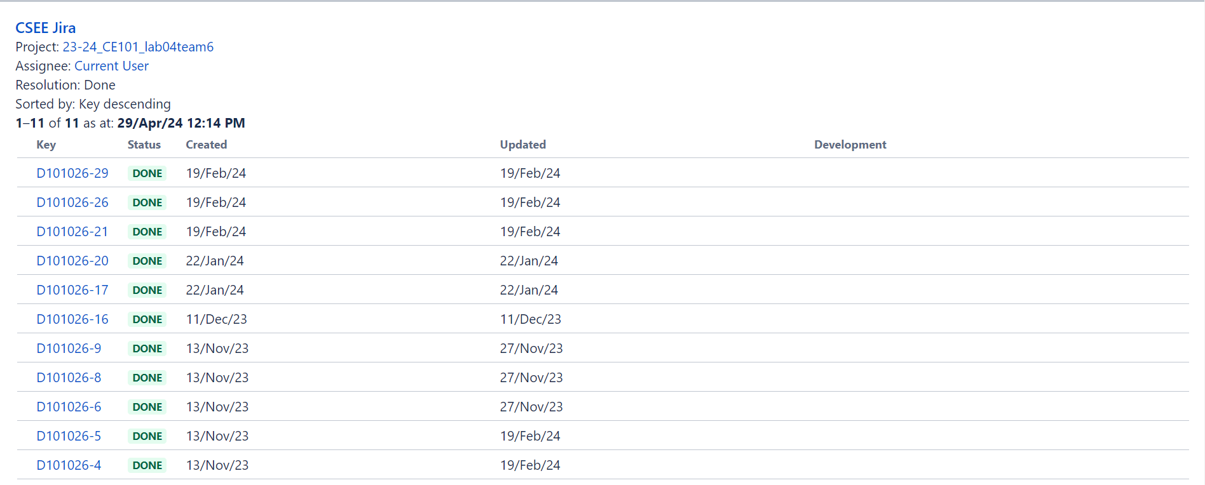
FIGURE 1 : THE TASKS DONE OUT OF 26
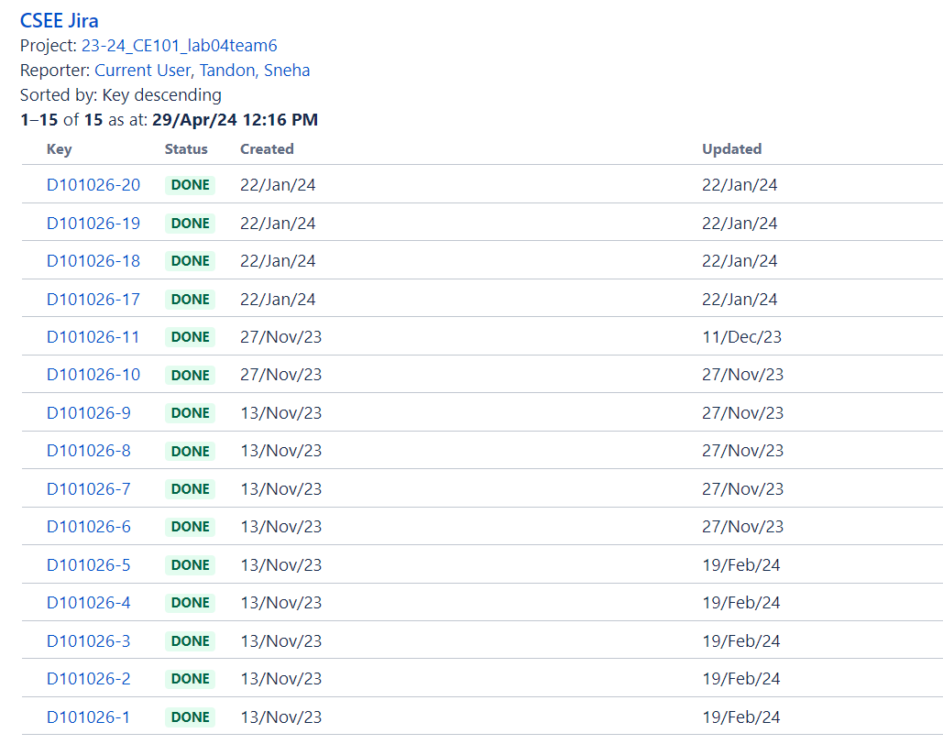
FIGURE 2 : THE TASKS ASSIGNED OUT OF 26

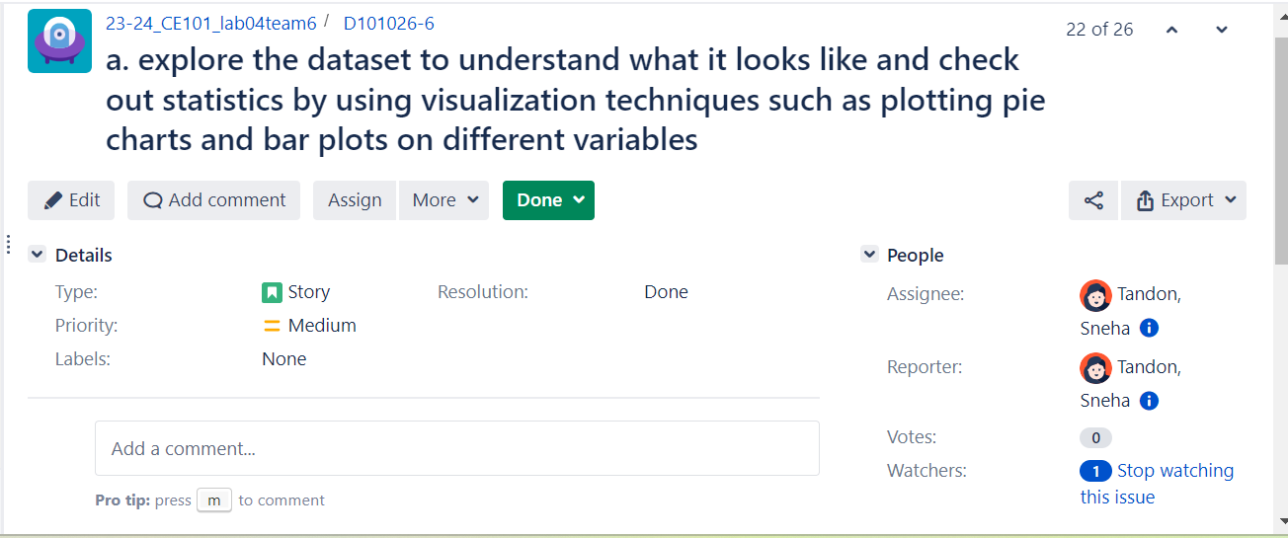
FIGURE 3 : ONE OF THE TASKS DONE BY ME

In my role as the Jira master and coder in our heart disease prevention project, I was responsible for several critical functions that directly influenced the success of our efforts. The development and refining of the code for the management and visual representation of our data, which was essential to the data analysis phase, was my main task. To make data understandable and accessible for both the team and stakeholders, I have made visual representations that range from tables with bar graphs to pie charts and boxes plots. In our Jira logs, these efforts have been meticulously documented to provide a clear picture of my contributions to the overall project. In addition, I have been instrumental in the integration of large datasets to ensure that data flows smoothly and precisely through our analysis.
From a project management perspective, I used Jira to organize and track our progress. This involved setting up the project's structure within Jira, updating tasks, and ensuring that all deadlines were met. To keep the project on schedule and to ensure that all members of the team are aware of their responsibilities and deadlines for their tasks, this systematic organization has been crucial.

My technical skills in coding and data management have been put to good use, reflecting what I've done well. I've been able to use my knowledge effectively to create functional and informative data visualizations that have had a significant impact on our project. The management of the project through Jira was also a strong point, as I kept the project organized and paced correctly to meet our milestones.

However, there were areas where I could have improved. While I've been able to manage my tasks efficiently, more frequent, and active communication would be useful. Regular meetings would help to improve strategic planning and facilitate a more effective solution of problems as they arise. In addition, it would be easier for me to adapt to unanticipated data challenges. Our results would probably have been optimized and delayed less if we had developed a more agile strategy for responding.

I have fulfilled most of my commitments with high standards in terms of the quality and timeliness of my work. I have completed all assigned coding tasks and Project Management responsibilities in a manner consistent with the time limit. The commitment to time limits has enabled us to maintain the project's momentum and ensure that we remain on track for early completion. The quality of my work generally met the project’s requirements, with the code I developed functioning effectively and supporting our analytical needs.

However, the integration of some data sets encountered minor problems, which were quickly resolved with the assistance of a team member and did not have a significant impact on the overall project schedule or results. However, there were no major discrepancies between what was promised and what has been delivered in spite of these minor problems. I have not only contributed to the success of this project, but also gained valuable insight into my strengths and areas for improvement.

Finally, my role as a coder and Jira administrator has allowed me to contribute greatly to our project in terms of technical solutions and organizational stability. This experience has provided me with a great deal of education, highlighting the importance of agile methodologies in managing tasks and responding to challenges which will be necessary for further projects where these skills are needed.

- Learning and Future Applications (words 371)

I've learned valuable lessons in both technical and interpersonal matters during my project. These experiences have not only enriched my understanding but also shaped my approach to future endeavors, particularly my individual project in the final year.

The critical importance of accurate data management and visualization was one of the most important technical lessons I've learned. When developing the code for generating insightful visualizations such as tables, graphs, and charts, the importance of presenting data in a way that is both accessible and useful has been understood. In my second and final year project, the presentation of clear data will be essential for analysis and decisions making.

The need for clear communication and regular interaction with team members was highlighted in terms of interpersonal management through the Jira system. I have learned that active communication is crucial to anticipate and resolve problems before they get out of hand, to sustain the project's momentum. I'm planning on starting more frequent inspections and discussions in my future team projects to ensure that the entire team is united.

I've been working with several key learning outcomes of the module through this project. For example, I have used a design methodology to systematically collect and analyses the data to ensure that it is comprehensive enough to support an appropriate conclusion. In line with the module emphasis on design principles, this approach was an integral part of developing a reliable model to predict heart disease. For the project management Jira for utilization for practical application of the agile methodologies taught in this module. This tool enabled us to track progress effectively, allocate tasks efficiently, and meet our project deadlines, which are fundamental aspects of successful project management.

Integration and management of data were also part of my role, ensuring the accuracy and reliability of our information sources. The focus of the module is strictly on rigorous data collection and management techniques, which are reflected in this systematic approach to data handling. I have been active in addressing various product context issues, e.g. ethics considerations and sustainability during this project. These are aligned with the module’s outcomes related to understanding aspects of product development to ensure that our given solutions were not only effective but also responsible.

- Conclusion (words 72)

This heart disease prevention project was a transformative experience that enhanced my technical skills in data management and visualization and sharpened my project management capabilities using Jira. The importance of transparent communication, proactive problem solving, and thorough data management is understood through reflection on this project. These key lessons have prepared me well for future challenges, ensuring I bring both technical expertise and effective teamwork to my upcoming projects and professional endeavors.

